Deep Codec Guru Website Phase-1 Requirement Document

1. Sign In and Sign Up page with Email Verification

**1.1 Sign In:** Details Required “Email/Phone/UserName and Password”

* **Email**: Must validate at time of Registration with Link or OTP
* **Phone**: Should be allowed to add under user profile after registration
* **UserName**: “First 4 letter from first Name” + “_” + “DDMMYYYY of user registered” [Auto generate after Sign UP]
* **Password**: Password reset process should be allowed Either via Verified Email Link or 3 Security Question out of 5 Security Questions [ Please, set some standard Security Question and follow market standard to collect the security questions info]

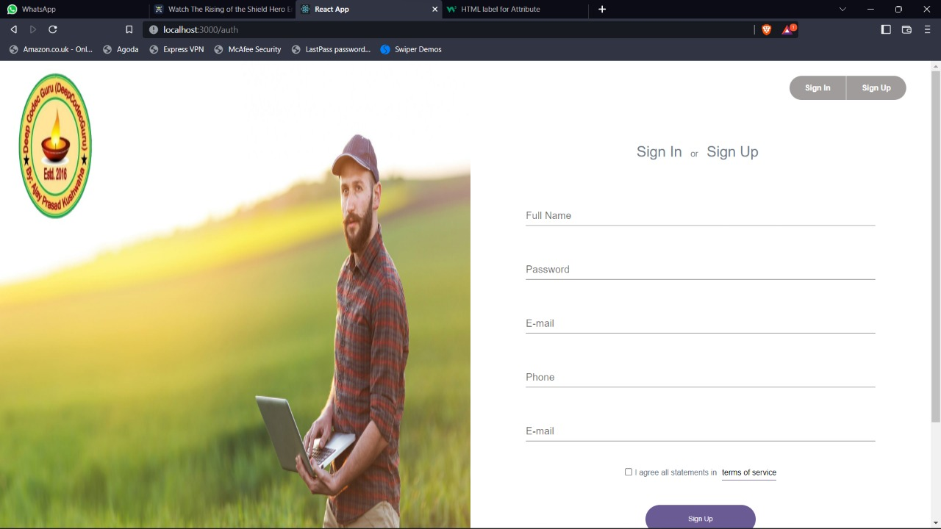

* 1. **Sign Up:** Details Required “Captcha verification, Full Name, Email, Password with retype for confirmation, Profession”
* **Captcha Verification**: Sign Up should be allowed only after Captcha verification [Any Captcha Verification method can be used]
* **Full Name**: First Name + Middle Name + Last Name
* **Email**: First Level Email Validation should be done as soon as user fill Email field and on Sign Up it should go under Email Verification Process before create account for user
* **Password**: Must be 8 characters [Combination of Upper Letter, Lower Letter, Number and Special character; For User example can be suggested with Invalid Password Warning; Password mismatch should only clean Password fields]
* **Sign Up should be also allowed with Microsoft/Google/Facebook accounts [Please, prefer Layout based on your recommendation or market standard]**

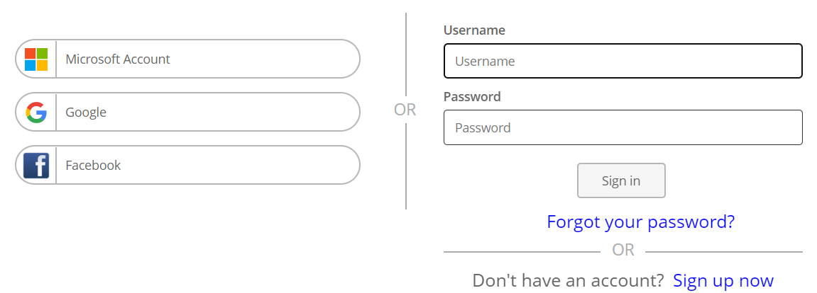

**Special Notes:**

**User Profile details should be created: My Profile, My Courses, My Badge, My Reward, My Certificate, My Coins, My Coupons, Security Questions, Learning Time, and Sign out**

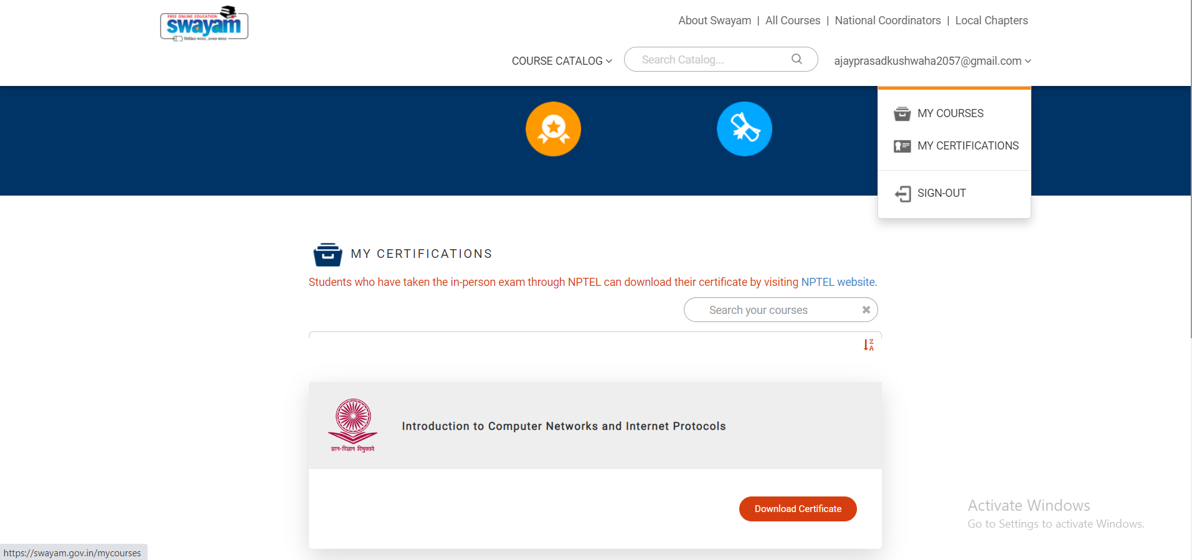

* **My Profile:** Must Contain User Photo with Upload feature, Email, Alternate Email, DOB, Change Password, Display Name, Aadhaar number, Father’s or Mother’s Name for Certificate, Qualification details optional to add, WhatsApp Number optional for notification, LinkedIn profile Link, Instagram profile link, About Me

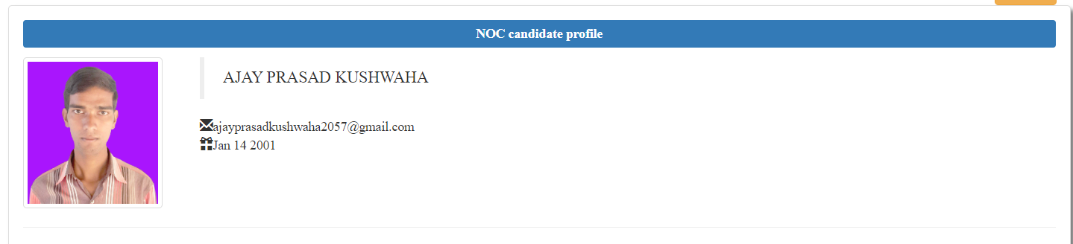

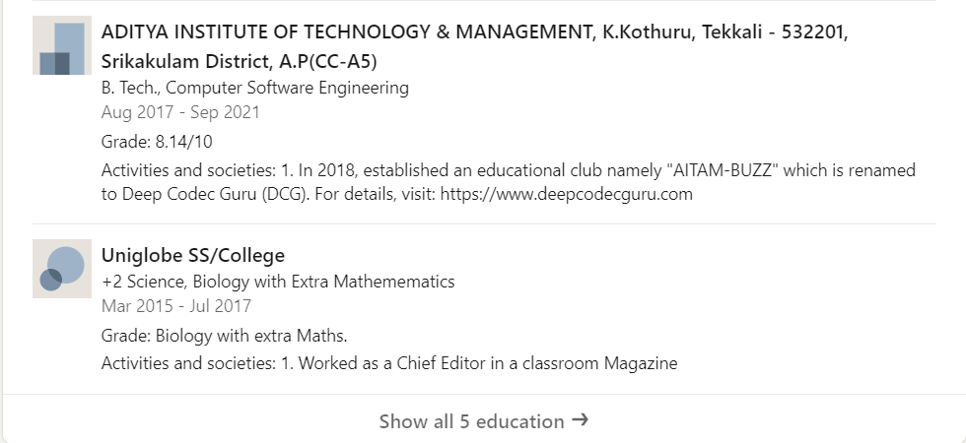

* **My Courses:** Should contains completed and ongoing courses

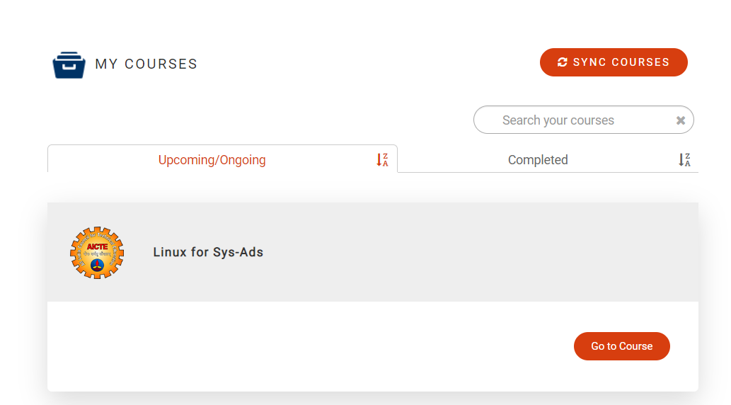

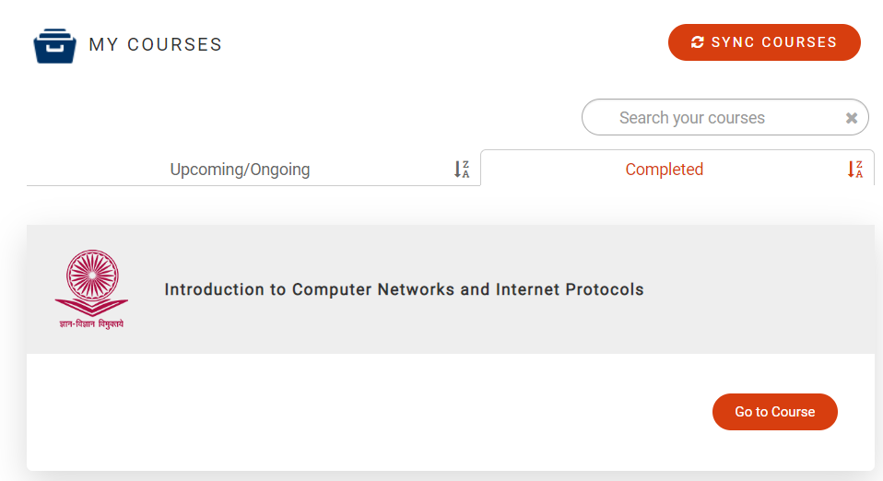

* **My Badge:** Badge on each course completion

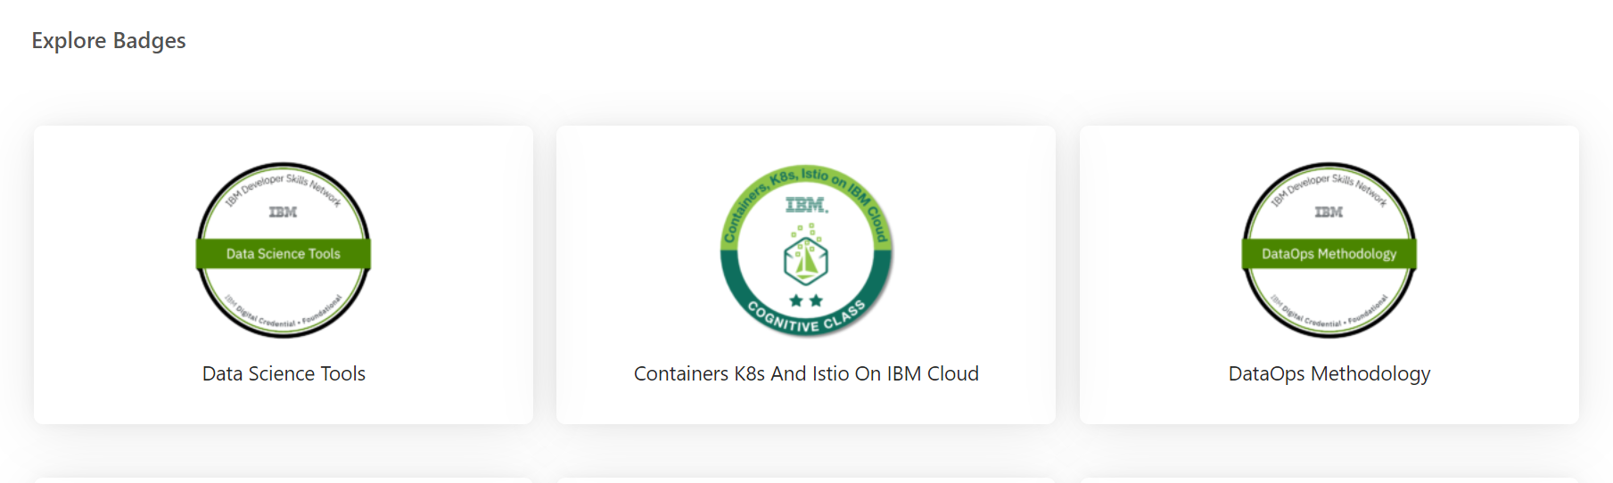

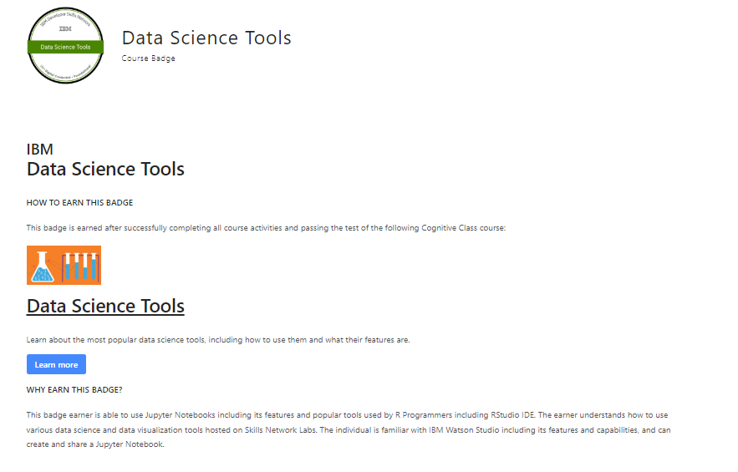

* **My Reward:** Under this Recognition certificate on joining Anniversary, attending multiple Events, Membership certificate and so on should be issued

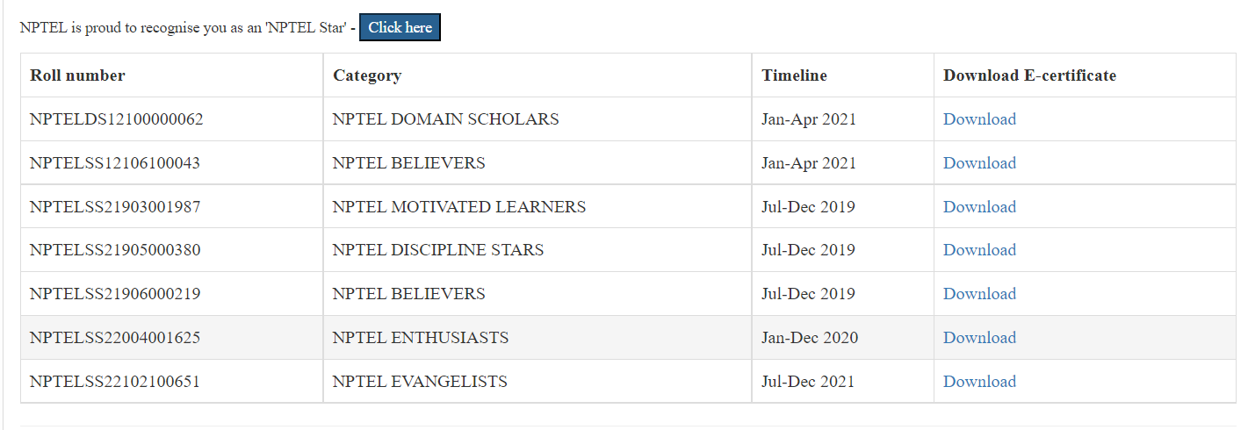

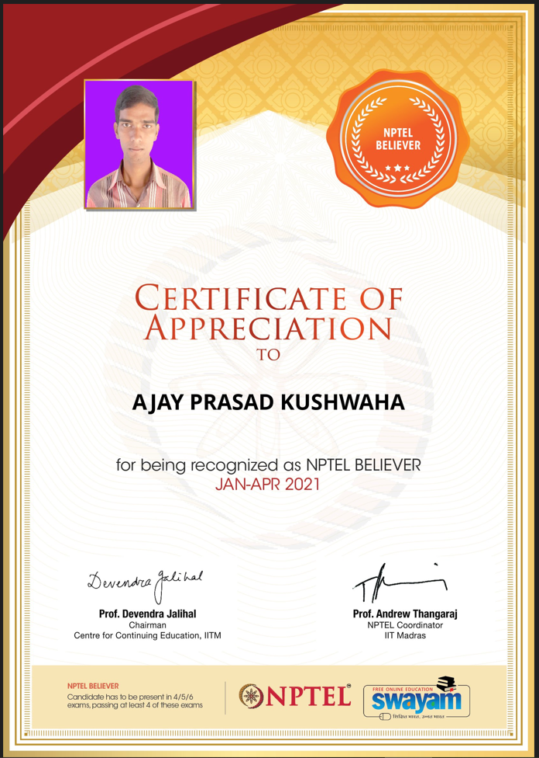

* **My Certificate:** Under this course and Others completion section [Certificate will be allow “Select for MarkSheet” or “Click Here to download” only if user has Redeem coins for the courses otherwise it will ask to Redeem coins to enable the feature; It should also allow user to share the Certificate on Social Media like LinkedIn, FaceBook; To enable share on Social Media Per Certificate 2 Super Coin should be used]

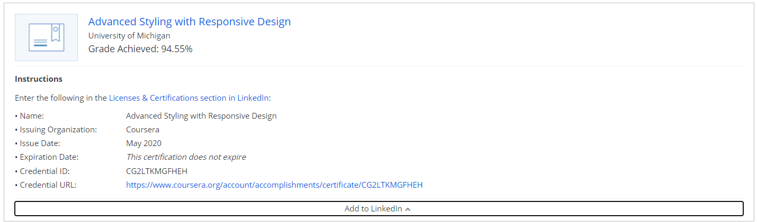

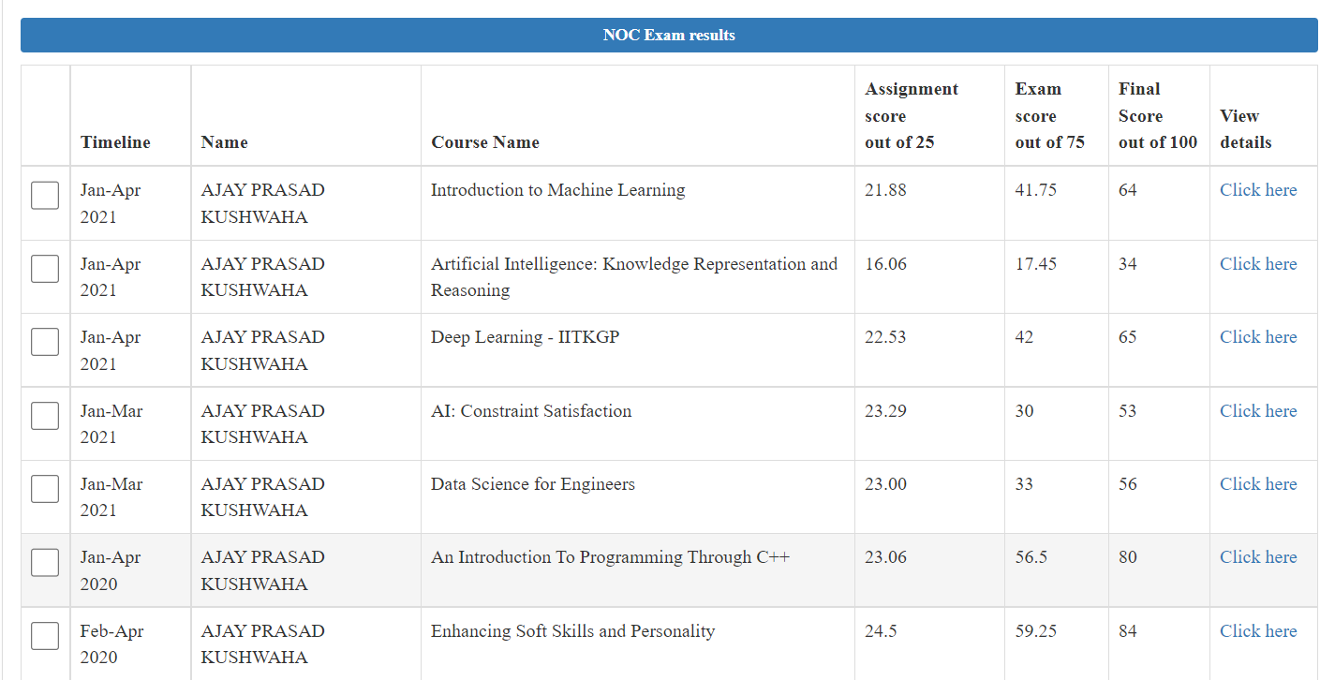

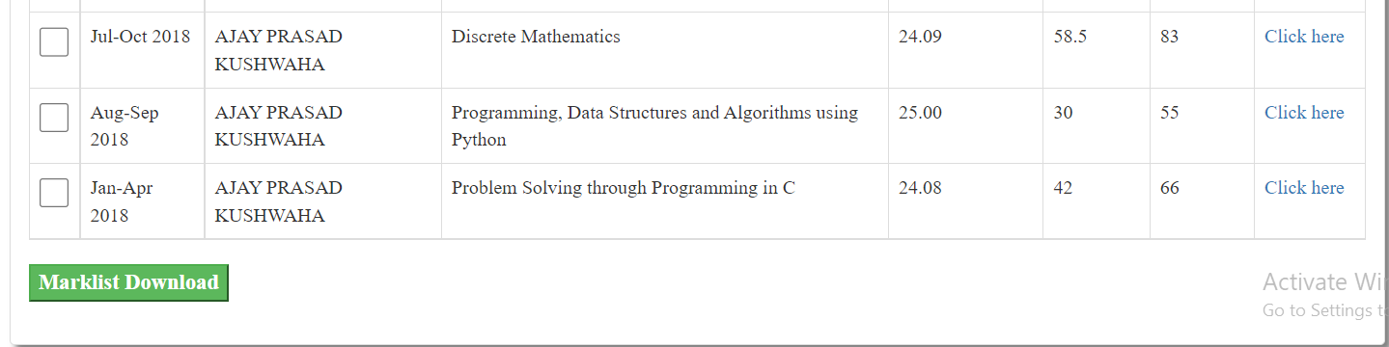

**As soon as click on “Click here”**

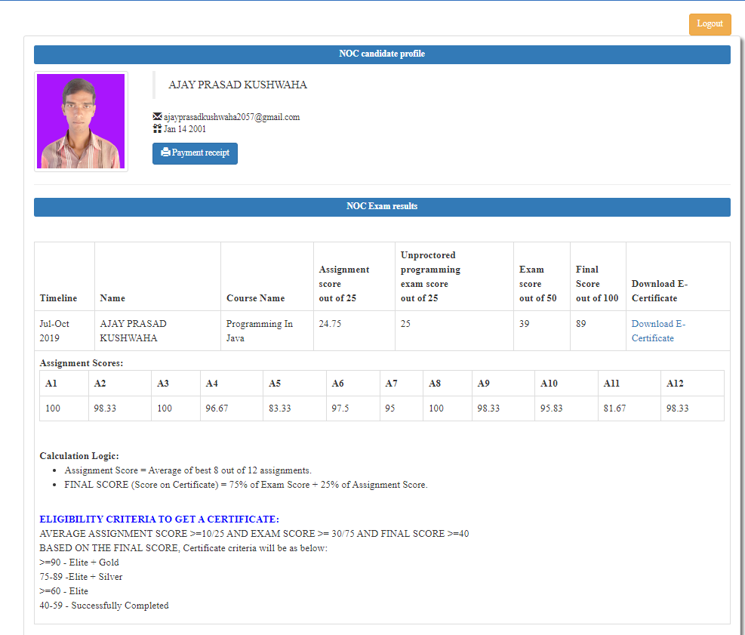

**As soon as click on “Marksheet Download” after selecting certificate name to be in Marksheet**

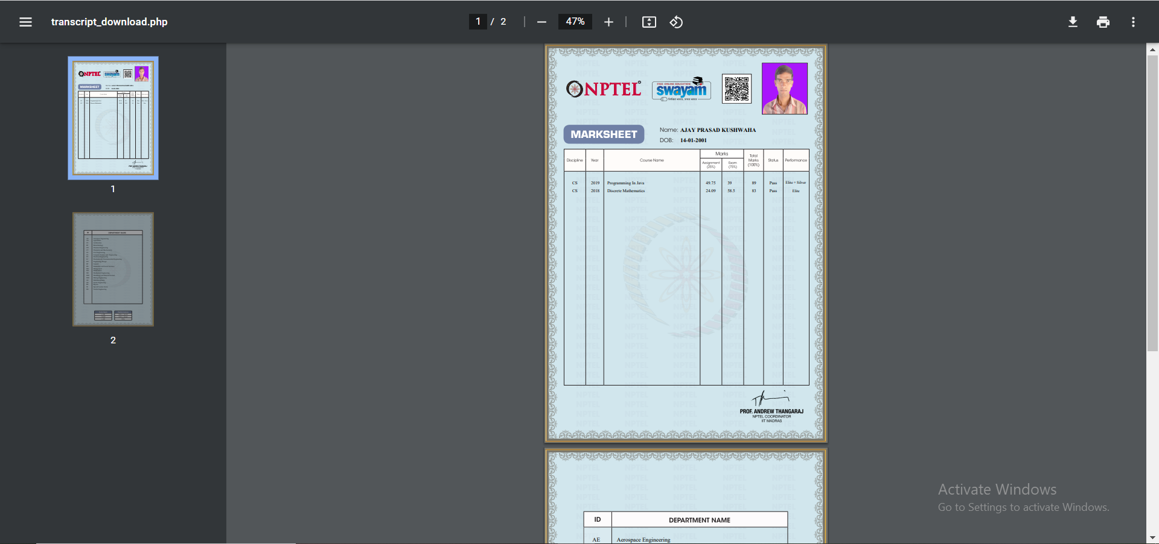

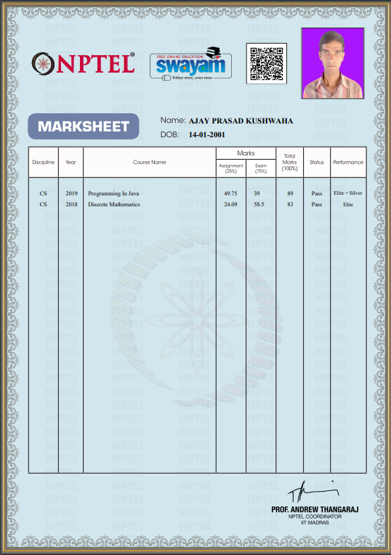

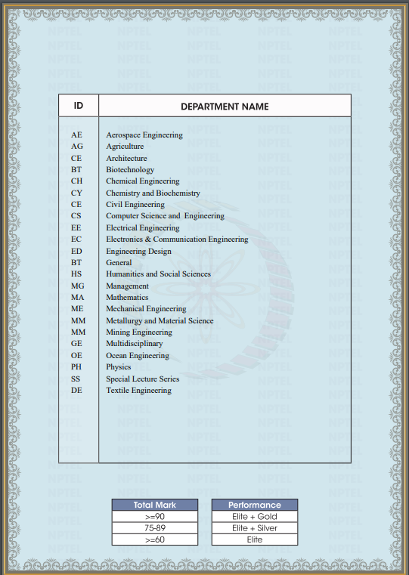

* **Course Certificate:** Certificate on each course completion should be issued
* **Others Certificate:** Event attended, Participated in contest, Appreciation certificate

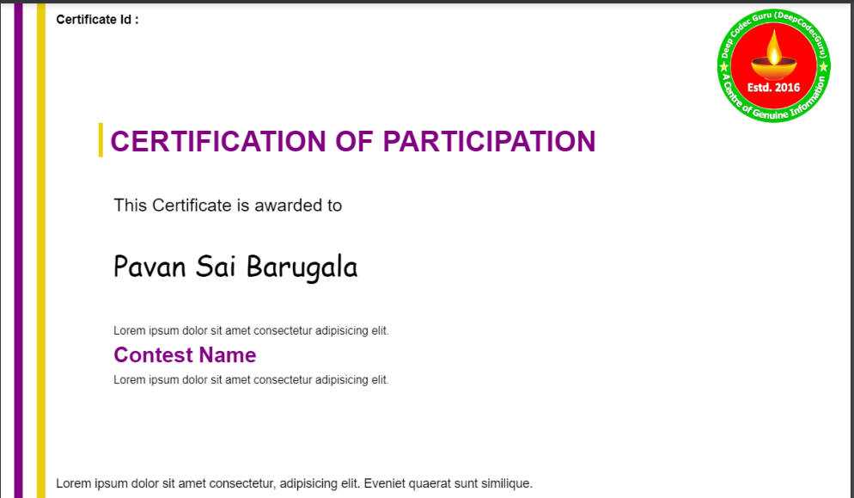

**QR code and Authentication Link should be added along with other options if looks good like Issued date**

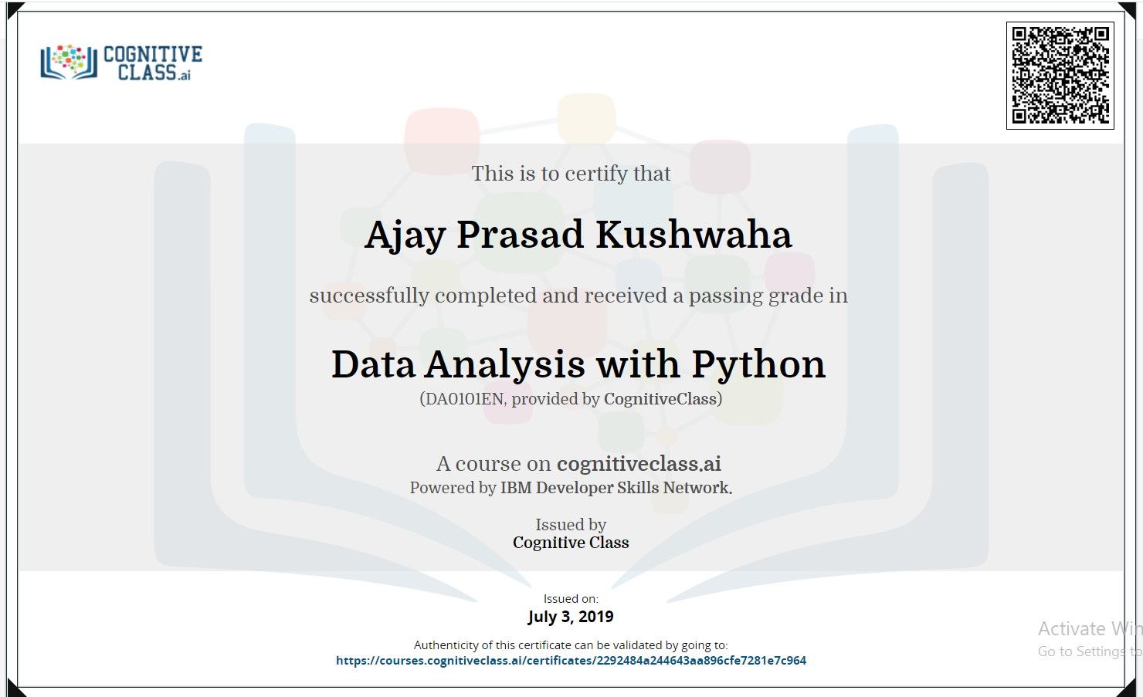

* **My Coins:** It should have “Earned Coins” and “Super Coins”
* **Earned Coin:** It can be earned on completion of each video/Module in Course (Max 90% from this coin can be Redeem only in a course at time of Course completion Certificate download, Remaining 5% should be used from Super Coin or Pay Equal amount; 1 Super Coin = INR.5)
* **Super Coin:** It can be bought using Payment Gateway or Can be Redeemed using **My Coupons** “Balance”
* **My Coupons:** My Coupons can be only used only for DeepCodecGuru Portal, Coupons Balance can be used to Redeem to buy **Super Coin.** Coupons can be also donated or shared with others. DeepCodecGuru Admin will create coupons on different occasions like Anniversary, Event promotion, as Reward on better performing learner
* **Security Questions:** Refer Password Reset Part Requirement [Password reset process should be allowed either via Verified Email Link or 3 Security Question out of 5 Security Questions. Please, set some standard Security Question and follow market standard to collect the security questions info]
* **Learning Time:** It should track the Login time to Log out time and add as learner spent time with DeepCodecGuru to previous duration [For 15 minutes ideal screen should warn 5 minutes log out and if ideal continues then it session should log out for user]
* **Sign out**

--Under Progress------

1. Every service can be seen on platform but after sign in only can be Enroll in Course or download some free material
2. After 2 or 3 video complete show the option to user “ To give feedback and rating “